|  |  |  |  |  |  |
| --- | --- | --- | --- | --- | --- |
| ****Entry ID**** | ****Date/Time**** | ****Entry Type**** | ****Duration**** | ****Topics**** | **Location** |
| ****1**** | **17-02-2023** | **Personal Work** | **5** | R&D project | Home |
| ****2**** | **28-02-2023 (2:00pm - 4:00pm)** | **Workshop** | **2** | Introduction to the BCIS R&D Project | AUT |
| ****3**** | **01-03-2023** | **Personal Work** | **1** | Schedule Table | Home |
| ****4**** | **06-03-2023 (6:00pm – 8:00pm)** | **Team Meeting** | **2** | Introduction | AUT |

# **Entry 1: 17 Feb 2023**

**The announcement about selecting our R&D project was released. And that we were to choose 5 projects that you are interested in. So, I did research on all the software developer projects because I am majoring in software. And found some interesting projects like the ZoomZ project,** Tooth Mate and Game Development **which were the topic I am hoping to get into. ZoomZ is the project I liked the most because it was based on a coffee app which is already been made and the goal of the project is to be able to** collect and analysis data and concept or recommendations to make improvements on the existing app.

**Duration: 5 hours**

# **Entry 2: 28 Feb 2023**

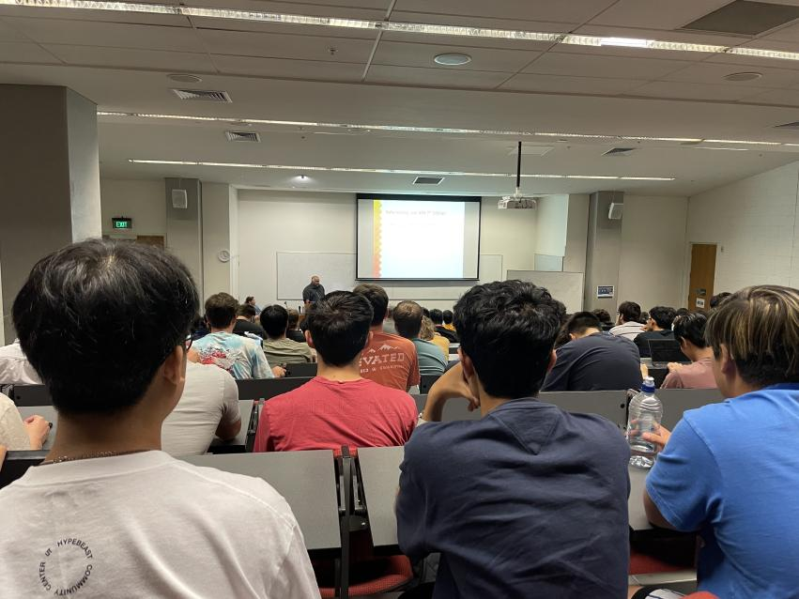On Tuesday at 2:00 to 4:00pm I had my first workshop on R&D. Ramesh and Jacqui went over the first week and what is expected to be done and how R&D paper works. At this point we haven’t received what project we be working on and what our team members are.

**Duration: 2 hours**

# Entry 3: 1 March 2023

An announcement was made for the teams and what project we will be working on. The project name was Digital Twin, which was none of my desire choices. I then did some research on what my project is and got into contact with my team. We fill out and schedule table seeing when everyone is free to host our first ever team meeting. And we decided to do it on Monday the 6th at 6:00pm, due to work and other university activities that my team and I had.

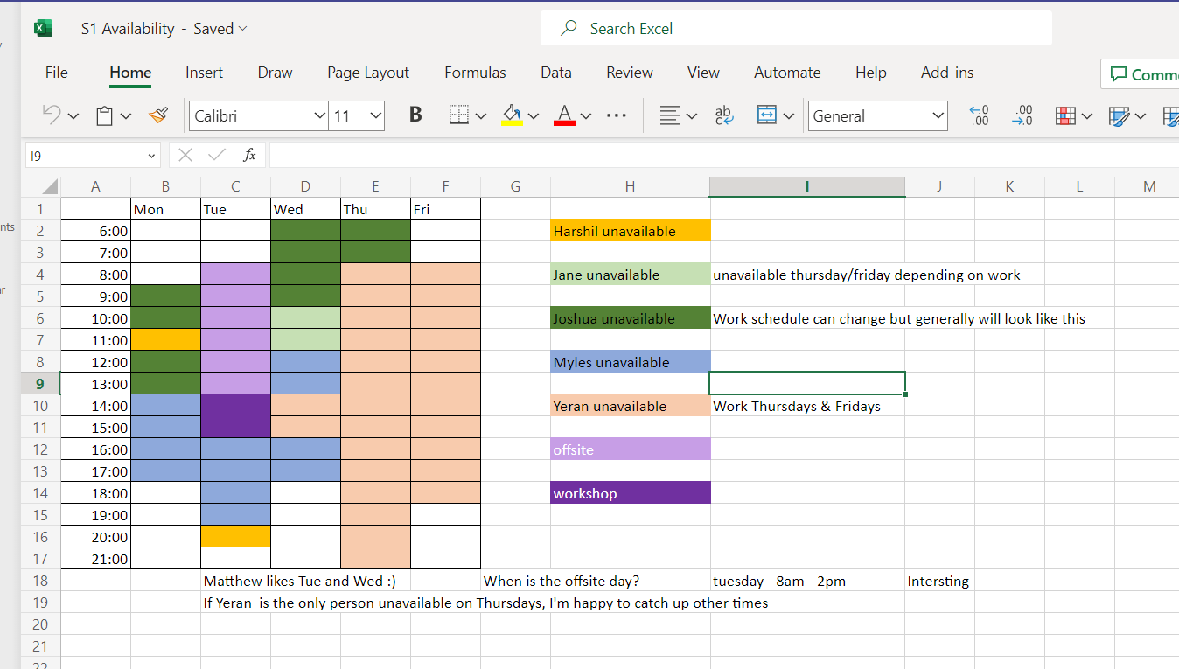**Duration: 1 hour**

# **Entry 4: 6 March 2023**

We had our first ever team meeting in one of the R&D rooms in WZ. We first all introduced ourselves and discussed who will be team leader. We also started planning if we want to use Trello, so that we can be ready for our meeting with our mentor on the 7th of March, which we will then know more about our project. But decided to use discord as the main method of communication between the team, until we had our meeting with our mentor.

Duration: 2 hours

# **Entry 5: 7 March 2023**

We had a meeting arranged with our mentor for the first time. In the building WZ floor 11 we had introduce us to the mentor (Matthew), but all of us already knew the mentor beforehand during last semester and the mentor had also remembered all of us. What we covered during this meeting is going over requirements for the project proposal, organizing client meetings, organize team meetings and plan work for the next week.

Duration: 2 hours

# **Entry 6: 7 March 2023**

In the RND room on floor 7 the team decided to sit down and work on the documents for the proposal. We split all the amount of work that we had on the things to do and dedicated to each member to complete:

We discussed a few things as well like what kind of framework we be using like agile, scrum, kanban.

We set up Trello and GitHub for the project.

[**https://trello.com/b/ZUD07vIC/portfolio**](https://trello.com/b/ZUD07vIC/portfolio)

[**https://github.com/emsoftaut/2023-RnD-Digital-Twin**](https://github.com/emsoftaut/2023-RnD-Digital-Twin)

Duration: 3 hours

# **Entry 7: 11 March 2023**

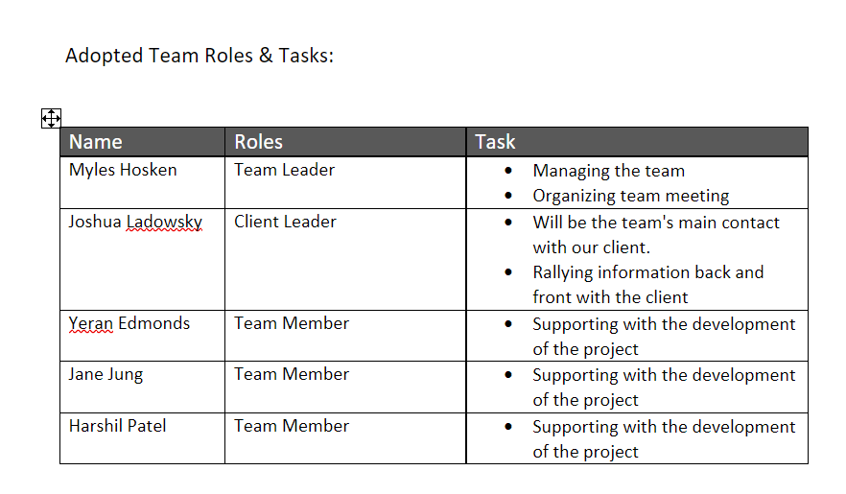I did a bit of reading and research on the different types of frameworks that the team could use. I also finished off working on my document which had been assigned. The document that I am working on is the Adopted Team Roles & Tasks.

Duration: 1.5 hours

# **Entry 8: 14 March 2023**

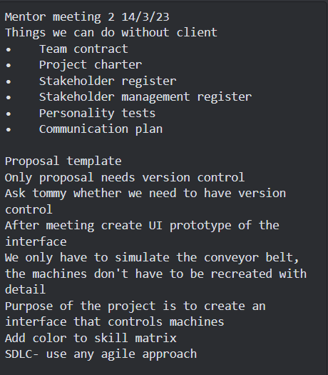We had our second meeting with our mentor. There was a lot of things we discuss, like the proposal template, personality test and which documents we can do without knowing the client’s requirements. We also discuss that we are meeting with the clients on Thursday and checking if everyone in the team can make it.

Duration: 2.5 hours

# **Entry 9: 14 March 2023**

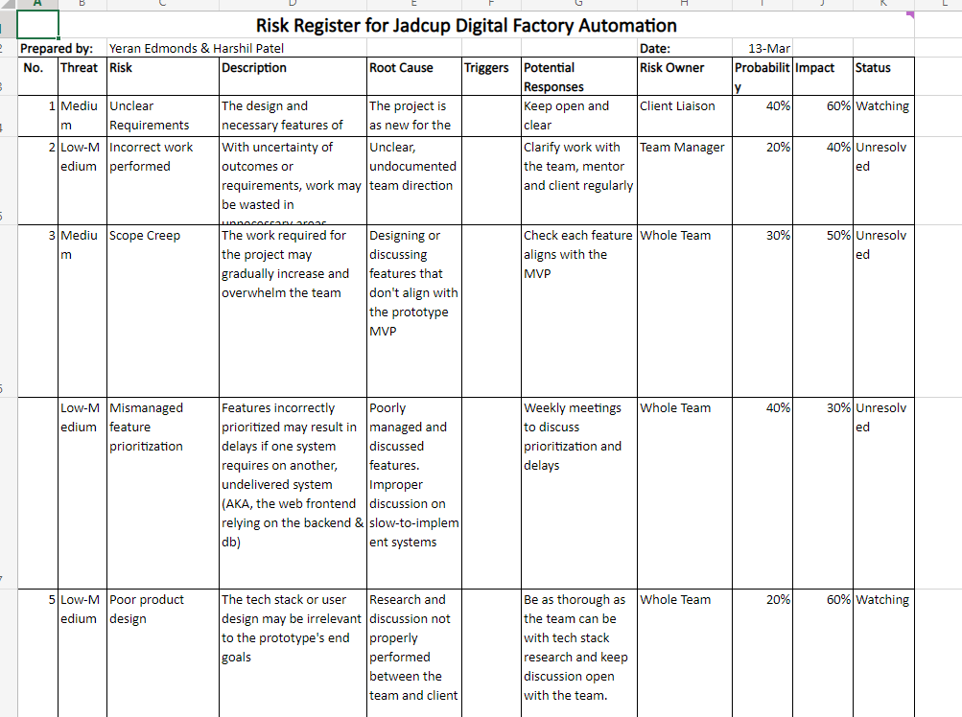After the meeting we went to one of the R&D rooms in the WZ building to work on the feedback that the mentor had given us to do during the week. I also worked on the Risk Register for Jadcup Digital Factory Automation, so that I can work on other documents that require some information from the client which the team will be meeting on Thursday the 16th.

Duration: 3 hours

# **Entry 10: 14 March 2023**

On Tuesday from 2:00 to 4:00pm I had a workshop on R&D.

**Duration: 2 hours**

# **Entry 11: 16 March 2023**

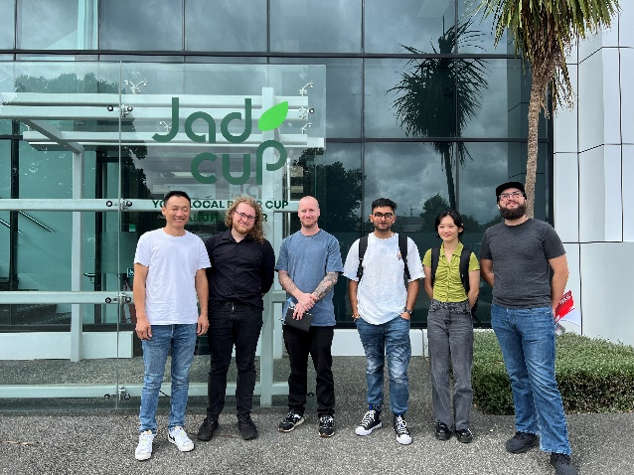We met our client for the first time. We started the meeting with an introduction, talked about what we are doing during the project and asked him a few questions on what he expects or wants for his outcome. Then he showed us around the factory and showed us how everything works and what we need to know, so that we can present a suitable prototype that he is happy with.

Duration 2.5 hours

**Entry 12: 18 March 2023**

On our weekly Saturday meeting we plan on doing every week, the team finalized the scope statement for the project. We also discussed what documents each of us will be doing now that we know what our client’s requirements. I was given the documents on milestone to complete before our next mentor meeting.

Duration: 3 hours

# **Entry 13: 21 March 2023**

We had our meeting with your mentor (Matthew), where we brought in the documents that we have been working on throughout the week as well as the current progress of our project proposal. And Matthew did a full review and given us some feedback on what we should expand on the main project proposal like the project methodology and WBS. We also ask him if he could give us feedback if we hand him a draft of the proposal, where he agrees to do so.

Duration: 1.5 hours

# **Entry 14: 21 March 2023**

As always, we head down a few levels to the R&D rooms to further discuss what each of us will be doing throughout the week. I was given to write a paragraph about the milestone as well as help think of ideas about storyboards that we might be using to break up the project feature to small subtask.

Duration: 2 hours

# **Entry 15: 21 March 2023**

On Tuesday from 2:00 to 4:00pm I had a workshop on R&D.

**Duration: 2 hours**

# **Entry 16: 24 March 2023**

Today the team hopped on the main document for the proposal and added more to the draft as well as implementing the suggestion that Matthew had made during our meeting on Tuesday. I kept working on my paragraph adding a few details which my teammate had suggested. Also, one of my team members had asked me to add a few new risk registers which she had suggested to me, which I also done. After the team was satisfied with the final draft, we sent it to Matthew.

Duration: 3 hours

# **Entry 17: 25 March 2023**

By the next day we had already received our feedback on the proposal, which the team then worked together and allocated everyone to clean up the draft to Matthew liking. Before the next mentor meeting.

Duration: 3 hours

# **Entry 18: 28 March 2023**

Today we had another meeting with Matthew, and we discussed with him the feedback which aroused during Saturday when we had been working on the feedback he had given. After he had finished answering all the questions, we had a small chat about the other groups and how their proposal was compared to ours.

Duration: 1 hours

# **Entry 19: 28 March 2023**

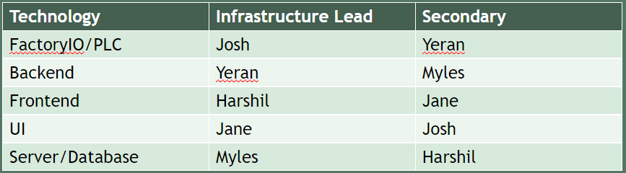We went down to the R&D rooms to discuss what needs to be done before we submit the final pdf version of the proposal by the 30th of March. We also about upskilling and who is upskilling on which part of the project. We had split the project into different stages or parts. I volunteer to be the lead of frontend of the project which I am upskilled on, as well as be secondary lead on database and servers.

Duration: 3 hours

# **Entry 20: 21 March 2023**

On Tuesday from 2:00 to 4:00pm I had a workshop on R&D.

**Duration: 1 hours**

**Entry 21: 30 March 2023**

Today was the day where we polish up our project proposal and sent it to Matthew and the moderator which was Tony. The team hopped onto a call to discuss any last minute’s changes or suggestions before finalizing it. After we had finished the team leader emailed it to Matthew and Tony.

Duration: 2 hours

# **Entry 22: 1 April 2023**

Now that we are done with the proposal, we now just had to make a presentation on the proposal which we will be presenting to the mentor and moderator. We will discuss what we will be talking about in the presentation and we all will be given one slide to work on before Monday night, so that we can meet on Tuesday and review what we have done and do a little trial presentation as practice.

Duration: 2 hours

# **Entry 23: 4 April 2023**

We had our final meeting before the proposal presentation in front of the moderator as well as break. We showed him our presentation slides and asked him a few questions about what is going to happen and how we are going to get in contact with the mentor and other stuff. He also gave feedback on the presentation, he was quite satisfied with it, but he gave us suggestion to make it better.

Duration: 1 hours

# **Entry 24: 4 April 2023**

After the meeting the team went to the level 4 R&D rooms in the WZ building and we worked intensely to get everything done before the massive presentation at 2:00pm. I continue working on my part and helped with making the slides more appealing like adding images.

Duration: 2 hours

# **Entry 25: 4 April 2023**

We had our proposal presentation in front of Tony and Matthew at WZ1101. We all were nervous, but all of us tried our best during the presentation and now we all we a bit relief. We were told after the presentation by Matthew, after he discussed the result of the presentation with Tony, and it seems like we will be receiving A- or A. Which we were all kind of happy to take, but we were hoping for an A*.

Duration: 1.5 hours

# **Entry 26: 8 April 2023**

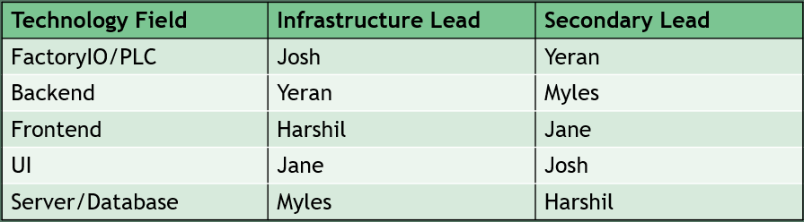In today’s meeting we discussed the different types of upskilling selection, where each of us will choose to upskill on throughout the 2-week mid semester break. Then we made a table which shows the finalize choose that each member made. We also went over the feedback that our mentor Matthew and moderator Tony had suggested to change in the proposal.

Duration: 3 hours

Week 7

# **Entry 27: 11 April 2023**

We had a little call because we were making final changes to proposal before final submission (project sched, milestone report).

Duration: 1 hours

# **Entry 28: 12 April 2023**

Today I started my first upskilling phrase, which I watch YouTube video on what is reacts and how to use visual studio code. The videos explained the concept of how to download and start coding in visual studio code. I had to download JS node and visual studio coder. I was able to start a fresh new project of the prototype dashboard for the R&D project.

How to start up a new project and how to use the platform: <https://www.youtube.com/watch?v=ORrELERGIHs>

Tutorial on how to use code with reacts:

<https://www.youtube.com/watch?v=Ke90Tje7VS0>

Duration: 4 hours

# **Entry 29: 13 April 2023**

Using the knowledge and understanding I got from yesterday’s upskilling, I watched a YouTube video on how to make a user interactive dashboard. While I watched I tried to follow along with some changes to suit my version of the project. However, I didn’t like how it ended up as well as it brought too much confusion while I followed along with it.

Dashboard video: <https://www.youtube.com/watch?v=wYpCWwD1oz0&t=5226s>

Duration: 4 hours

# **Entry 30: 13 April 2023**

Continuing from today’s morning upskilling. As I watched the remaining parts of the video and tried to follow along, I started to feel confused in understanding terms and concepts that he uses in the video. However, I still followed along with the video I had a genetic idea on how to make a rough draft and simple dashboard.

Dashboard video: <https://www.youtube.com/watch?v=wYpCWwD1oz0&t=5226s>

Duration: 4 hours

# **Entry 31: 14 April 2023**

The team had a meeting with Matthew showing him what each of us had done during the week for the upskilling. Myles and Yeran showed what they had done with factory io and server. Since I had nothing to show Matthew for upskilling, he requested that I have something by next week mentor meeting.

Duration: 1 hours

Week 8

# **Entry 32: 18 April 2023**

I decided to give up on my pervious upskilling work, so I tried to look for a new video that I could work on as part of my upskilling. I found a really good video that uses firebase as an external server which is connected to the dashboard which is quite similar to what we are doing for our project.

New Video: <https://www.youtube.com/watch?v=JiQyKsbRulg&t=1390s>

Duration: 4 hours

# **Entry 33: 20 April 2023**

I looked for another video on dashboard which might be easier to implement and found one which uses a framework called tailwind, which makes CSS simpler to use due to its coding format as well as allows you to access libraries that makes dashboard prettier. Had some trouble downloading the tailwind onto my visual studio code.

Tailwind: <https://www.youtube.com/watch?v=pfaSUYaSgRo>

Dashboard video using tailwind: <https://www.youtube.com/watch?v=ypRJ9ScLmco&t=2420s>

Duration: 4 hours

# **Entry 34: 21 April 2023 (3:30 - 4:30pm)**

We had a mentor meeting with Matthew, where we went over our progress with upskilling and showed off what we had done so far. Since I couldn’t show what I had done last Friday for upskilling I had shown what I had done today. I briefly went over the layout out and explain this could be a potential design we could use for the Jadcup dashboard, which he was quite impressed with and satisfied with.

Duration: 1 hours

Week 9

# **Entry 35: 29 April 2023 – (**9:30 -12:00pm)

In today’s Saturday meeting we went over the four major topics which are:

* Finishing proposal based on Tony’s recommendations.
* Updating main with frontend code
* Factory IO
* Server/database

Tony had a view thing that he had noticed in the proposal which didn’t satisfy him; therefore, he ask the team to make some changes in the project proposal which the team immediately implemented. As for the Factory IO and Server/database they were being managed by the other members of the team (Josh, Myles and Yeran), where they were testing and figuring out why they were getting errors upon running the simulation.

The front-end code I had requested is a pull request, so that I can merge my work with the main branch which then we can further develop throughout the semester. Then Jane had accepted the request now my frontend code is on the main branch. 😊

Duration: 3.5 hours

Week 10

# **Entry 36: 2 May 2023 – (**9:30 -11:00am)

Today the team met up at 9:30am to get a quick list of agenda done for the mentor meeting at 10:00am. In the list of agenda, we had:

* Showcasing the Factory IO
* Showcasing the Server/database
* Reviewing the proposal with Tony recommendations with mentor
* Asking a question related to the mid-term review.

A minute before 10:00am we packed our things and went up to the meeting floor at WZ1101 and went in when Matthew had arrived. As I mention we went through the list of agenda that needs to be discussed and showcase. Matthew is quite impressed by what we did during the previous week.

Duration: 1.5 hours

# **Entry 37: 2 May 2023 – (**11:00 - 12:00pm)

After the meeting we went down to the RnD room on level 4 to finish the last bit of touches on the proposal that Matthew we should add for Tony before sending it to him. As well discuss what would be an ideal time to meet since the team is quite inconsistent in staying for the whole duration of the meeting on Saturday.

Duration: 1 hours

# **Entry 38: 2 May 2023 – (**2:00 - 4:00pm)

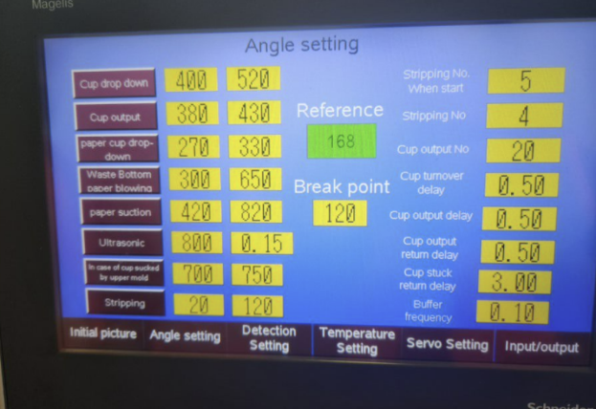After having lunch, the team meets back up at the Rnd room on level 7 WZ building. Where we sat and discussed some potential GUI design as well as looked at the already existing GUI that Jadcup has:

We were wondering if we would need to make a GUI design having all these values for the main product and the protype. Which then we add for question to ask Matthew.

The team members that were working and looking after the factory IO were testing and playing with the factory simulation, so that they can figure out how to send data to the frontend which I had poorly implemented.

Duration: 2 hours

# **Entry 39: 6 May 2023 – (**9:00 -12:30pm)

In today’s Saturday meeting we went over the two major topics which are:

* Status Report
* More Server/database

We tried to get as much of the status report done, because some of the members in the team needed to leave early due to personal reasons, so we tried to get as much of the status report done. By the time the members we had a completed template done so that we allocate someone to one section to work on, but we hadn’t done that since then we were under pressure to get as much done. However, I continue to work on the status report and meeting minutes, as for the other members that didn’t leave continue, they worked on the database/server.

Duration: 3.5 hours

Week 11

# **Entry 40: 9 May 2023 – (**9:30 -10:00am)

The team met up for 30 minutes before the mentor meeting at 10:00 to quickly go over what needs to be covered for today’s mentor meeting with Matthew.

Today’s mentor meeting agenda:

* Web application Units on website
* Factory I/O - Licensing issue
* Worklog book hours

Duration: 0.5 hours

# **Entry 41: 9 May 2023 – (**10:00 -11:00am)

In today’s mentor meeting we went over a few different problems and questions we had for our project so far. One is the website application, factory IO and workbook hours.

We ask a few question on the website application, which we thought the values that are relevant and that do we need to unincluded this data on the website as well these are some issues we addressed:

* Units on webpages are not required to be precise.
* Create some fictitious data to represent irrelevant values.
* Send just some of the transferable data to the middleware while keeping all of the buttons visible (all input/output buttons are required).

We ran into an issue that our factory io licensing issue got expires so we couldn’t work on the simulation for the prototype. We discuss these points with Matthew:

* The team couldn’t use the factory IO program because our license isn’t working and for the factory io to work, we would need to upgrade our current license to ultimate.
* Build the prototype without the Milestone report.
* Sensors control real machines but, in the simulator, we must control manually.

 We had an issue that 110 hours is quite a lot of hours and that want confirmation that do we need that many hours spent towards RnD, and that Matthew said: yes.

Duration: 1 hours

# **Entry 42: 13 May 2023 – (**9:00 - 12:00pm)

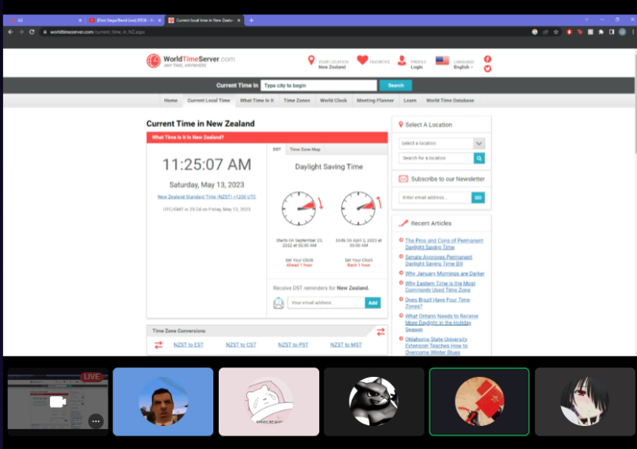

In today’s Saturday meeting, we started working on the proposal, which the team got an email from Tony saying that he wanted a few parts to change and elaborate on.

After an hour of that we quickly went over the status report and filled out the template that was created by Jane and Josh. We work down from title page, executive summary, and project overview.

Then we proceeded to work on the meeting documentation, in which every member of the team opened their worklog book and cross refences every entry and date we had made, which then confirm the date and what topics we discussed during that meeting and enter it into the table on the status report.

Duration: 3 hours

Week 12

# **Entry 43: 16 May 2023 – (**9:30 -10:00am)

As always, the team met up for 30 minutes before the mentor meeting at 10:00 to quickly go over what needs to be covered for today’s mentor meeting with Matthew.

Today’s mentor meeting agenda:

* Iteration Scheduling
* Question & Answer
* Status report

Duration: 0.5 hours

# **Entry 44: 16 May 2023 – (**10:00 -11:00am)

After our little session we then made our way up to WZ floor 11 for our mentor meeting with Matthew. And we went over the agenda:

Iteration Scheduling:

We believe it will be beneficial for everyone to spend time together on the Kanban board on Tuesday for each iteration. We can shift the cards around at this time. Every time someone moves a card, they should note WHY they are doing so as well as what they intend to do with it once it is in a column (for example, how they want to develop it).

Question we ask Matthew:

* Ask Matthew if we need a new schedule Ask Matthew about the cards (see trello) Ask Matthew about testing.
* Ask Matthew for the booking.
* Ask Matthew about meeting minutes (do we need to make all the meeting minutes)
* Ask Matthew to review status report (and ask about page count)
* Ask Matthew to confirm proposal changes.

Status Report:

We tried to get Matthew to look over the status report, however he was running late to something, so he had left 30 minutes after the meeting had started. He did ask us to send it over to him on Friday morning.

Duration: 1 hours

# **Entry 45: 16 May 2023 – (**11:00 - 1:00pm)

After the meeting with Matthew the team were headed to the 4th floor to work on the UI design of the dashboard, which we were running behind by a few days and that we needed to have a rough UI design of what the actual dashboard would look like. Myles and Yeran were working on their factory IO simulation where me, Jane and Josh were thinking of ideas of what we should have for the dashboard like adding headers and sidebar. After some rough draft, Josh used software that he had on his 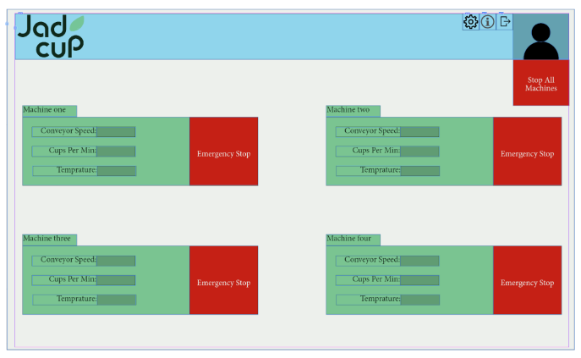device to make a clean and polished UI design. As for me and Jane, we continue working on the UI for the other contents of the dashboard.

Duration: 2 hours

# **Entry 46: 16 May 2023 – (**2:00 - 4:00pm)

On Tuesday from 2:00 to 4:00pm I had a workshop on R&D.

Duration: 1 hours

# **Entry 47: 19 May 2023 – (**7:00 - 7:30pm)

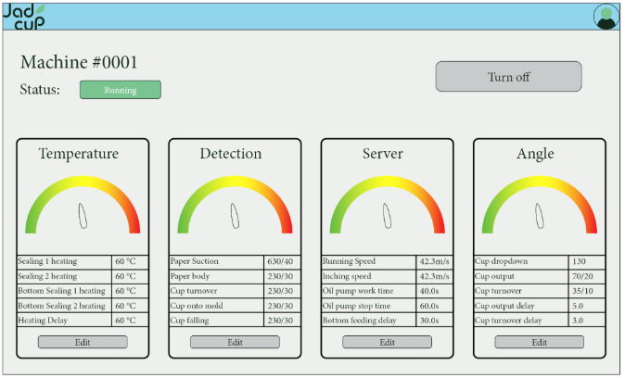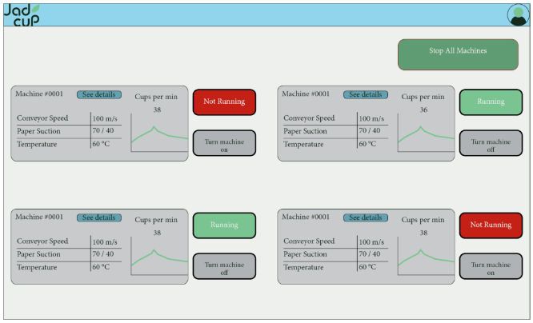Me, Josh, and Jane had a quick meeting for finalizing the UI design so that we can send that to Matthew and Daniel for approval so that we can finish of the second iteration. These were the final and polished UI design that we ended up with:

Duration: 0.5 hours

# **Entry 48: 20 May 2023 – (**9:00 - 12:00pm)

At the meeting on Saturday morning, we continued working on the status report. We use the PowerPoint slide on canvas as a guide on what needs to be covered and put onto the status report. We have already done the meeting documentation on the title page.

The team was able to complete a few points of the status report quickly since some part required was already stated in the project proposal, however the team encountered a few questions relating to the status report like the page count, what is required in some sections of the status report and referencing the proposal.

Duration: 3 hours

Week 13

**Entry 49: 23 May 2023 – (**9:30 -12:00pm)

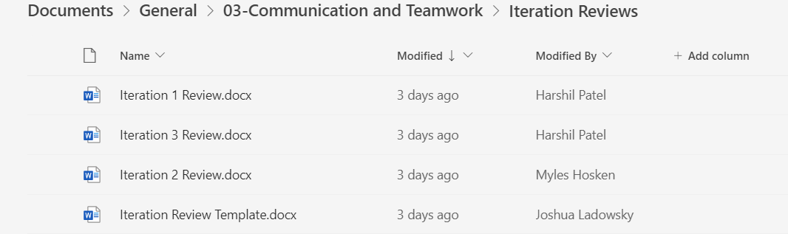The team meeting started off with discussing what we are going to do with iteration review. We were missing iteration review for 2 iteration 1 and 2, which the team decided to do one at the end of each iteration. So, the team got together and reviewed the iteration for 1 and 2, the team member made a small template which we would fill out at the end of each iteration.

We also updated the skill matrix from our previous matrix to the more recent skill set, which is after the upskilling stage of the project. In the last 30 minutes or so I worked on the meeting documentation table where we were still missing details in the topic discuss column, which me and Jane completed together.

Duration: 2.5 hours

# **Entry 50: 23 May 2023 – (**2:00 - 3:00pm)

In today’s mentor meeting with Matthew, we had to go through a few agenda quickly due to Matthew needing to leave early for personal reasons.

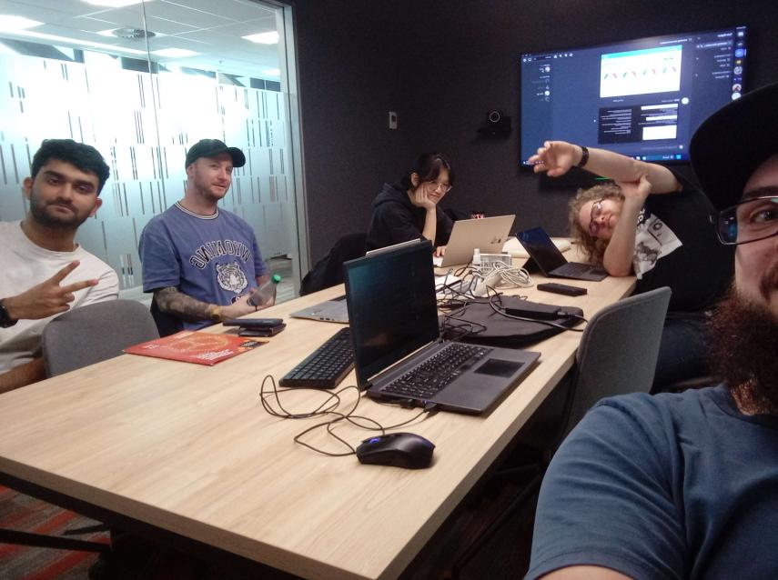We went through a few questions that we had to discussed like:

* Ask Matthew about the cards (see trello)
* Ask Matthew about testing.
* Ask Matthew if we need a new schedule.
* Ask Matthew to confirm proposal changes.

We also ask about what we needed for the mid-term review:

* Do we need to update old plans in the proposal e.g. we updated issue log in proposal
* Do we need to update doc in portfolio as well

We tried to get Matthew to look over our status report and double check what needs to be change, however we nearly ran out of time, so instead we ask him if we could book our presentation for mid-term review on the 13th week because the team were quite busy in week 12 as well as the mentor. So, Matthew told us to ask Ramesh, that we hold our presentation either next week or week 13 (preferably week 13 6/7 of June).

Duration: 1 hours

# **Entry 51: 25 May 2023 – (**7:00 - 8:00pm)

I hopped on the status report because I had forgotten to calculate the total time I have spent on this project since week 1. I opened an excel sheet that Jane had made, which I would have to enter the total hours I spent each week including the two weeks of break, which will tally up and calculate my overall time spent.

I then enter the total amount in the status report. So that we Myles can sent the status report to Matthew by Friday morning so that he can review it and give us feedback.

Duration: 1 hours

# **Entry 52: 26 May 2023 – (**1:30 - 2:30pm)

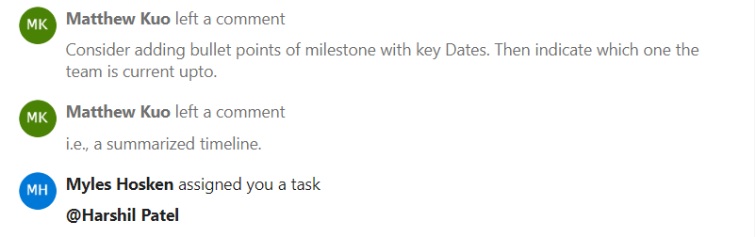 We had gotten feedback from Matthew for the status report and Myles had assigned me two task to complete the for the feedback given.

I hopped on and finished off the feedback assigned to me.

Duration: 1 hours

# **Entry 53: 26 May 2023 – (**5:40 - 6:10pm)

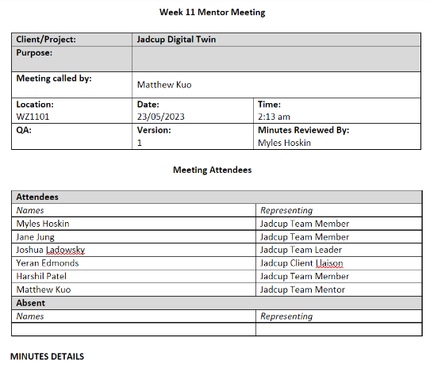We had no meeting minutes not completed for this month in the team folder, which I volunteered to complete and fill I started doing the meeting minutes for the May month. I had completed 2 weeks of meeting minutes before hoping off to complete my other paperwork.

Duration: 1 hours

# **Entry 54: 26 May 2023 – (**7:35 - 8:35pm)

I had found some time to continue working on the meeting minutes for the rest of the month. After 1 hour of working on the meeting minutes I had completed all the meeting minutes for this month.

Duration: 1 hours

# **Entry 55: 27 May 2023 – (**9:00 - 12:00pm)

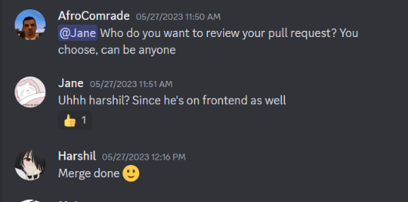We had quick meetings for the team members that needed to go early and what we had discuss during the meeting is to think about the changes that gets brought up by either the client or the mentor, as well as iteration planning using Kanban, which including to do list inside the cards of task that needs to be completed. After 11:00am two of our members had to leave mid-way due to personal reasons, however I stayed back and finished the last missing meeting minutes for the previous months with the help of Yeran. Jane also had a pull request made for the front end which she wanted me to look at and accept after checking if everything is right.

Duration: 2.5 hours

Week 14